**SCTP property of the pc object**

If you will remember, earlier on in this course, when we set up our peer connection object, I showed you that all data channels will use SCTP.

And at the time we were dealing with it, the sctp property of the peer connection object was null.

However, if you examine the sctp property later in the negotiation process, you'll see it populated like this:

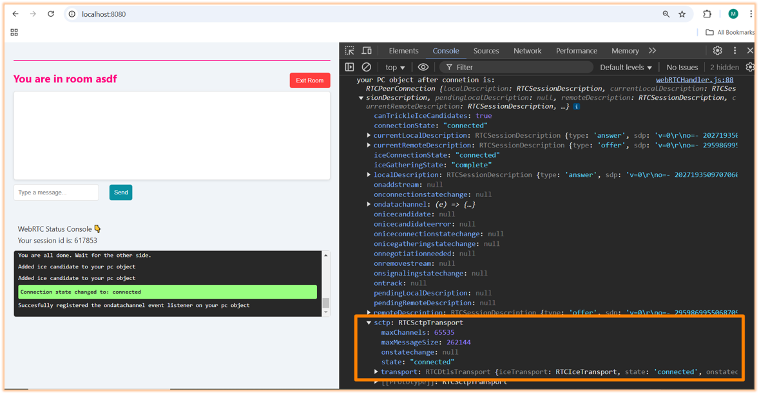

I wanted to give you a few pointers on what this is.

#### What is RTCSctpTransport?

**RTCSctpTransport** is an object that represents a transport layer for the Stream Control Transmission Protocol (SCTP). SCTP is a transport layer protocol (fancy word for "rules") used to transmit data channel messages over WebRTC.

#### Key Properties

* **maxChannels**: This property indicates the maximum number of channels that can be established using this SCTP transport. I already discussed this perviously, but to remind you, the number of **65535** is the theoretical limit defined by SCTP.
* **maxMessageSize**: This property specifies the maximum size of a single message that can be sent over a channel. Here, it is set to **262144** bytes (or 256 KB), meaning any message exceeding this size will need to be fragmented (fancy word for "chunked" or "split-up").
* **onstatechange**: This property allows you to define a callback function that will be invoked whenever the state of the SCTP transport changes. If it’s currently **null**, it means no callback has been assigned yet.
* **state**: The current state of the SCTP transport. In our case, it shows **"connected"**, indicating that the SCTP connection has been successfully established between peers.

#### What about media streams?

For media streams (audio and video), WebRTC uses another protocol!

I know ... so many protocols.

Specifically, media streams use the Secure Real-time Transport Protocol (SRTP). SRTP is designed specifically for real-time media transmission, providing encryption, message authentication, and integrity.

#### Summary

* **RTCSctpTransport** is responsible for managing data channels in your WebRTC application.
* There are multiple transport objects within a single RTCPeerConnection—one for data channels (SCTP) and others for media streams (RTP/SRTP).
* SCTP is dedicated solely to non-media data communication while RTP/SRTP handles audio/video streaming securely.

This architecture allows WebRTC to efficiently manage different types of communication simultaneously.

Pretty cool, right?